


iSP – AWS Landing Zone
High Level Design
Prepared by: Mark Kelly | 14 July 2025



Contents

1. Document overview 3
1.1. Project Background 3
1.2. Document Purpose 3
1.3. Workload-Dependent Design Decisions 3

2. Solution Overview 4
2.1. What is an AWS Landing Zone? 4
2.2. Core Components 4
2.3. Logical Architecture 5
2.4. Multi-account Architecture 6
2.5. AWS Landing Zone – Organisational Units 7
2.6. AWS Landing Zone – Core Accounts 7
2.7. AWS Landing Zone – Primary AWS Services 9

3. Deployment approach 11
3.1. Landing Zone Accelerator (LZA) 11
3.2. Landing Zone Accelerator – Config Files 11
3.3. Landing Zone Accelerator – Deployment 11
3.4. Account Factory for Terraform (AFT) 12
3.5. AFT Repositories 13
3.6. Account Factory for Terraform – Deployment 13

4. Network Architecture 15
4.1. Hub & Spoke Topology 15
4.2. Hub Virtual Private Cloud (VPC) 17
4.3. Egress Design 19
4.4. Ingress Design 19
4.5. Ingress & Egress Traffic Flows 21

5. Security 22
5.1. IAM Identity Center 22
5.1.1. SSO Login Page 22
5.1.2. Root Identities 23
5.1.3. Securing Root Identities 24
5.2. AWS Web Application Firewall 25
5.3. AWS Network Firewall 26
5.4. AWS Security Hub 26
5.4.1. AWS Foundational Security Best Practices v1.0.0 27
5.5. AWS Cognito 27

6. Account Governance 29
6.1. Platform Baseline Configuration 29
6.1.1. Global Config 29
6.1.2. Organisation Config 31
6.1.3. Accounts Config 33
6.1.4. IAM Config 33
6.1.5. Network Config 34
6.1.6. Security Config 35

7. Cost Management 39
7.1. Consolidated Billing 39

Version Control
Date | Version | Changed By | Reason for Change
20/06/2025 | 0.1 | Mark Kelly | Initial Draft
11/07/2025 | 0.2 | Mark Kelly | First Peer Review
18/07/2025 | 1.0 | Mark Kelly | Published to iSP

Circulation List
Name | Organisation/Title
Stuart Briner | Group Head of EdTech / iSP
Matt Knowles | Group Head of Technology / iSP
Vik Paw | Group MIS Manager / iSP
Craig Duffield | Capability Owner / iSP
Joanita Radivoev | Delivery Manager / Version 1
Shane Mitchell | Head of Private Sector Presales / Version 1
Mark Kelly | Cloud Architect / Version 1
Nick Walters | AWS DevOps Engineer / Version 1
Richard Polley | Senior Business Analyst / Version 1
Lenson Saldanha | Tech Lead / Version 1
Shekhar Kumar | Tech Lead / Version 1
Mihir Pandya | Tech Lead / Version 1

Reference Documents
Document Title | Description | Owner
iSP AWS Landing Zone - Operational Runbook.pdf | This document provides information for the users that will operate the AWS Landing Zone on behalf of iSP. It contains instructions on how the Landing Zone was deployed, common scenarios and findings discovered during development of the Landing Zone. | Nick Walters
iSP – Architectural Design Decisions.xlsx | This document captures the key Architectural Design Decisions (ADDs) that govern the setup and evolution of iSP's AWS estate, specifically tailored to support AI-related development. The primary purpose of these ADDs is to ensure consistency across all cloud environments, promote standardisation from a deployment and operational perspective, and establish a secure platform for all future AI initiatives. | Mark Kelly

Document overview

Project Background
In Q2 2025, Version 1 conducted an AWS Well-Architected Review of iSP’s AI Toolbox application. This architectural assessment evaluated the application against five core pillars: Security, Operational Excellence, Reliability, Performance Efficiency, and Cost Optimisation. The primary objectives of this exercise were to identify areas for improvement, identify security vulnerabilities, and evaluate the long-term viability of both the application and its underlying platform.
The review surfaced a number of critical gaps spanning all five pillars. While some of these findings were specific to the application's immediate architecture and have since been addressed, a significant portion highlighted a broader lack of platform-level competency and consistent governance. The implementation of an AWS Landing Zone was proposed as the strategic solution to address and resolve these fundamental shortcomings, thereby establishing a more secure and scalable cloud foundation.

Document Purpose
This document is intended to provide a high-level, overarching view of the AWS Landing Zone solution and its core components. To complement this document, a separate Landing Zone Operational Runbook document has also been developed. Please see the Reference Documents table to source this document.

Workload-Dependent Design Decisions

When navigating this document, please refer to the hand icon placed throughout. This icon indicates design decisions that are intentionally left open at this High-Level Design (HLD) stage, as they are dependent upon the onboarding of specific workloads and their individual requirements. These pending decisions will be addressed during the application onboarding phase to ensure alignment with application specific requirements.

Solution Overview

What is an AWS Landing Zone?

An AWS Landing Zone provides a standardised, secure, and automated foundation for all your cloud workloads. It's essentially a pre-configured AWS environment that sets up multiple accounts with built-in security and compliance controls, all aligned with the AWS Well-Architected Framework. This code-first approach ensures consistent configuration and governance across iSP’s entire AWS footprint.
Leveraging core AWS services such as AWS Organisations, AWS Control Tower, and AWS Config, an AWS Landing Zone will give iSP enhanced control and visibility over their AWS environment. From an EdTech perspective, this translates directly to reduced downtime, increased availability of essential learning applications, and a more secure, reliable platform for their educational needs.

Core Components
Organisation | Role
Organisation Structure | Multiple Oranisational Units are deployed to provide a level of governance across multiple AWS accounts
Account Breakdown | AWS recommended multi-account approach is established to isolate workloads and environments
Security | AWS security services are deployed in every account and centralised in the dedicated Security OU
Identity & Access Management | IAM Identity Center provides SSO capabilities across all AWS accounts
Account Guardrails | Service Control Policies and AWS Control Tower guardrails are applied at the OU and account levels
Hub & Spoke Topology | A Hub VPC is deployed to facilitate a Hub & Spoke network topology
Firewall Capability | A firewall capability is deployed to route and inspect various traffic flows across the AWS estate by way of the AWS Network Firewall service
Centralised Logging | A centralised Log and Archive account collects and aggregates platform logs from across the Landing Zone
Cost Management | Billing and cost details are centralised in the Consolidated Billing Management account for invoicing, reporting, and alerting
Account Vending | New AWS account creation is automated via the Account Factory

Logical Architecture
The diagram below illustrates a logical architecture of the AWS Landing Zone with respect to the personas – Administrators, Platform Engineers and Developers - that operate at each layer: Management, Operations & Application Development.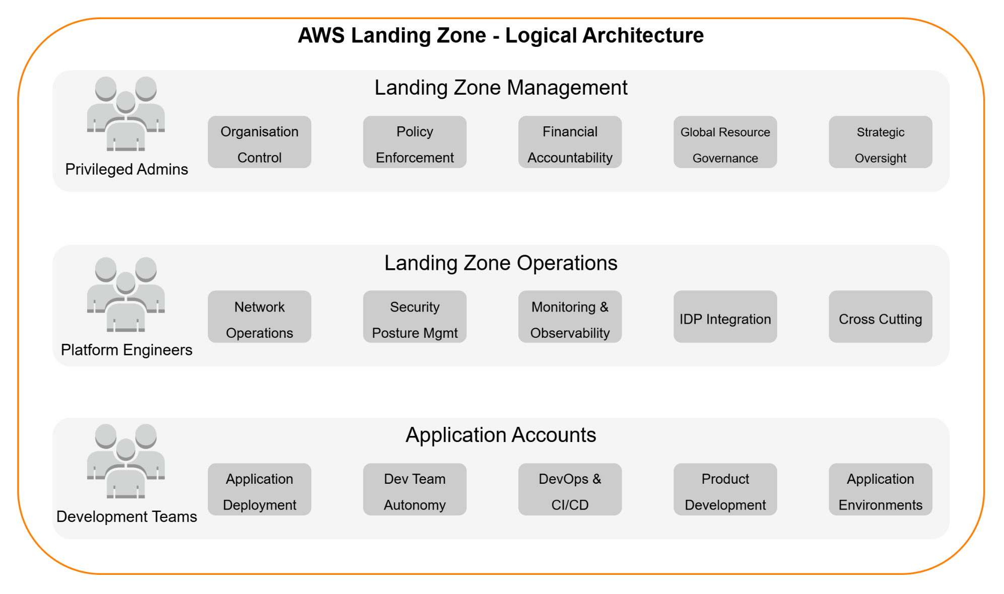
Figure 1 AWS Landing Zone - Logical Architecture

Multi-account Architecture
The diagram below illustrates the hierarchical multi-account Landing Zone architecture as well as the Organisational Units deployed as part of this engagement.
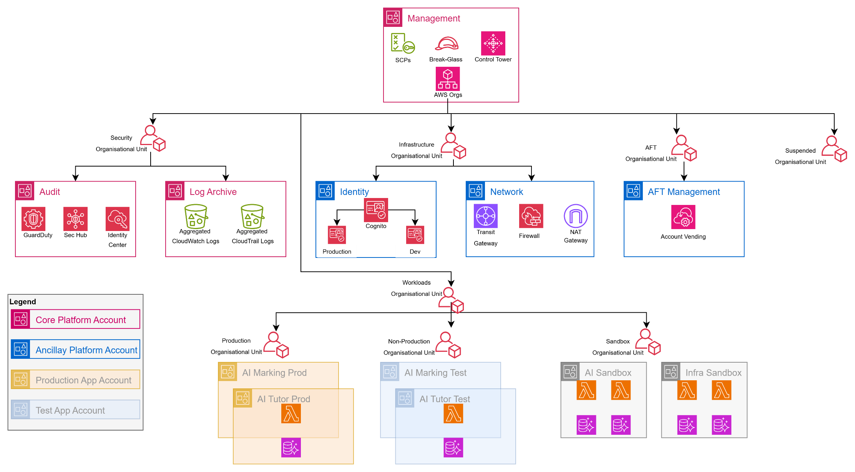
Figure 2 AWS Landing Zone - Account Hierarchy

AWS Landing Zone – Organisational Units
An Organisational Unit (OU) in AWS is a logical grouping of AWS accounts. It acts as a container that allows organisations to group and categorise multiple AWS accounts into a hierarchical structure.
The primary purpose of OUs is to simplify the management and governance of an AWS environment by applying common policies and controls to groups of accounts. This is particularly powerful when used with Service Control Policies (SCPs), which define the maximum permissions that can be granted within accounts belonging to a particular OU.
The following table describes the OUs deployed as part of the Landing Zone solution.
OU | Role
Management | The top-level Organisational Unit, primarily containing the AWS Organisations Management account. It serves as the administrative root for the entire multi-account environment, hosting core services that manage and govern the organisation.
Security | Dedicated to centralising security services and controls. It houses accounts for security auditing (i.e., Log Archive & Audit) and incident response, ensuring compliance monitoring and unified security posture across the organisation.
Infrastructure | Designed to host shared infrastructure accounts (e.g., Network, Shared Services). This OU contains resources and services that are common dependencies for multiple workloads and are managed centrally, such as Transit Gateways, shared VPCs, or (potentially) directory services.
Workloads | A logical grouping that serves as a parent container for accounts hosting application and service environments. It provides a hierarchical structure to organise various Sandbox, Test, and Production deployments.
Production | Contains AWS accounts specifically allocated for live, mission-critical application deployments. This OU is subject to the most stringent security, operational, and change management controls to ensure stability and compliance for Production workloads.
Non-Production | Houses AWS accounts designated for development, testing, staging, and quality assurance environments. Controls here are typically more relaxed than in Production, allowing for agility in development while still maintaining a secure baseline.
AFT | An OU specifically designated for accounts provisioned and managed by AWS Control Tower's Account Factory for Terraform. It facilitates automated, customised account creation and lifecycle management through Infrastructure as Code.
Sandbox | Provides isolated AWS accounts for experimental development, proof-of-concept work, and learning. These accounts offer a high degree of autonomy to users (Developers and Engineers) but are typically subject to strict cost controls and are isolated from production environments.

AWS Landing Zone – Core Accounts

The following table describes the primary AWS accounts deployed as part of the Landing Zone solution.
Account / ID | OU | Role
Root / 971476708498 | Root | This is the primary account of the AWS Organisation and the central point for billing, Service Control Policies (SCPs), and overall management of other AWS accounts. This account hosts the core Landing Zone Accelerator pipeline and automation services (CodePipeline, CodeBuild, Lambda functions) responsible for vending and governing new accounts (via AWS Control Tower’s Account Factory service), as well as managing the organisational structure.
Audit / 867251710378 | Security | A highly restricted, dedicated account for centralising all security and compliance-related logs and resources. This includes consolidating AWS Config recordings, GuardDuty findings, Security Hub aggregates, and other security service outputs from all accounts across the organisation. Access to this account is limited to security and compliance personnel only.  It also integrates with AWS IAM Identity Center (formerly SSO) for centralised access management.
Log Archive / 184870496997 | Security | A dedicated account for long-term, immutable storage of all organisational and operational logs. This includes CloudTrail logs, S3 access logs and VPC Flow Logs. Its primary purpose is secure, centralised, and immutable log retention for compliance, auditing, and troubleshooting.
Network / 656113190452 | Infrastructure | Dedicated for centralising network infrastructure that spans multiple accounts across the entire organisation. This includes AWS Transit Gateway (for inter-VPC routing), centralised egress points, and shared DNS services. Consolidating networking here simplifies management and enhances security.
Identity / 415519078652 | Infrastructure |   TBC – an iSP wide design decision is required to assess whether a centralised Identity account is warranted to manage the creation of AWS Cognito pools.  A dedicated account to facilitate federated identities from a centralised IDP e.g. OneLogin & ClassLink. This account will host AWS Cognito pools which applications (AI Tutor, AI Marking) will interface with to provide an authentication layer.
Account Factory / 340084177880 | AFT | A dedicated account to host services associated with account provisioning using Account Factory for Terraform (AFT). This will host the AFT related AWS CodePipeline and AWS CloudFormation Stacks that will consume the Terraform configuration and generate workload AWS accounts (AI Marking Test, AI Marking Production accounts) and any customisation configuration.

AWS Landing Zone – Primary AWS Services
The following table describes the primary AWS services deployed as part of the Landing Zone solution.

AWS Service | Role
AWS Organisations | This is the foundational service for managing multiple AWS accounts. It facilities the consolidation and management of multiple AWS accounts under a single, unified billing and management entity. Its primary purpose is to help iSP centrally govern the AWS estate as it scales.  AWS Organisations is primarily configured and managed from the Management Account.
AWS Control Tower | AWS Control Tower builds on AWS Organisations to set up and govern a secure, multi-account AWS environment i.e. the Landing Zone, according to best practices. It automates the setup of the platform’s core accounts (Management, Log Archive and Audit accounts), configures guardrails (both preventative and detective), and provides a dashboard for continuous monitoring and compliance. It acts as an orchestration layer for many underlying AWS services.  AWS Control Tower is deployed and managed from the Management Account. When set up, it automatically provisions the Log Archive and Audit accounts
Account Factory | The Account Factory is a feature of AWS Control Tower that automates the provisioning of new AWS accounts that are pre-configured with your organisation's established baseline (e.g., connected to AWS Organisations, enrolled in Control Tower's guardrails, pre-integrated with central logging and auditing). This ensures consistency and compliance for every new account from day one.  Terraform will be leveraged to manage Account Factory to create new application-level accounts. The new accounts themselves are created as Member Accounts under the organisation.
AWS Config | AWS Config provides a detailed inventory of your AWS resources, tracks their configuration changes over time, and evaluates these configurations against desired rules (e.g., "S3 buckets should not be publicly accessible").  AWS Control Tower automates the deployment of Config rules from the Audit account. AWS Config is enabled in each Member Account to record local resource configurations. However, to provide a layer of observability across all accounts, its findings and configuration history are aggregated centrally in the Audit account.
Service Control Policies | SCPs are a type of organisation policy that provide a mechanism for managing permissions across the AWS organisation. They provide centralised control over the maximum available permissions for all accounts in your organisation or specific Organisational Units (OUs). SCPs do not grant permissions; rather, they set guardrails by defining what actions users and roles within member accounts are prevented from doing, even if an IAM policy in that account explicitly grants the permission.
Identity Center | Centralises access management to all accounts within the AWS Organisation. It enables single sign-on access to AWS accounts and any applications using an existing corporate directory (e.g., Active Directory) or its own managed directory. It defines permissions at a centralised level and propagates them across the various member accounts via permission sets.
Security Hub | Provides a comprehensive view of the overall security posture across the Landing Zone. It collects security findings from various AWS services (GuardDuty, Config), aggregates them, and provides automated security checks against best practices and compliance standards.

Deployment approach

Landing Zone Accelerator (LZA)
The AWS Landing Zone Accelerator (LZA) is an open-source solution designed to automate the rapid deployment of a secure, scalable, and compliant multi-account AWS environment. Built upon AWS best practices and aligning with various global compliance frameworks, LZA leverages Infrastructure as Code (IaC) principles through AWS Cloud Development Kit (CDK) and a set of YAML configuration files.
It extends the foundational capabilities of AWS Control Tower by providing enhanced customisation for security controls, network topology centralised logging, auditing, and automated account provisioning. This significantly reduces the upfront manual effort in establishing a cloud foundation, enabling iSP to accelerate their cloud adoption while maintaining strict governance and security posture.

Landing Zone Accelerator – Config Files
At the heart of the AWS Landing Zone Accelerator solution are six YAML configuration files: accounts-config.yaml, global-config.yaml, iam-config.yaml, network-config.yaml, organisation-config.yaml, and security-config.yaml. These declarative files serve as the primary interface for iSP to define and customise the desired multi-account AWS environment.Therefore, the solution warrants a dedicated GitHub repository to version control these configuration files. The table below captures the GitHub repo and link to same.
Repo Name | GitHub Link
isp_aws_landing_zone_configuration | International-Schools-Partnership/isp_aws_landing_zone_configuration: ISP Landing Zone Config

Landing Zone Accelerator – Deployment
The diagram below illustrates a high-level overview of how the iSP managed Landing Zone Configuration repository relates to the AWS components that comprise the Landing Zone solution.
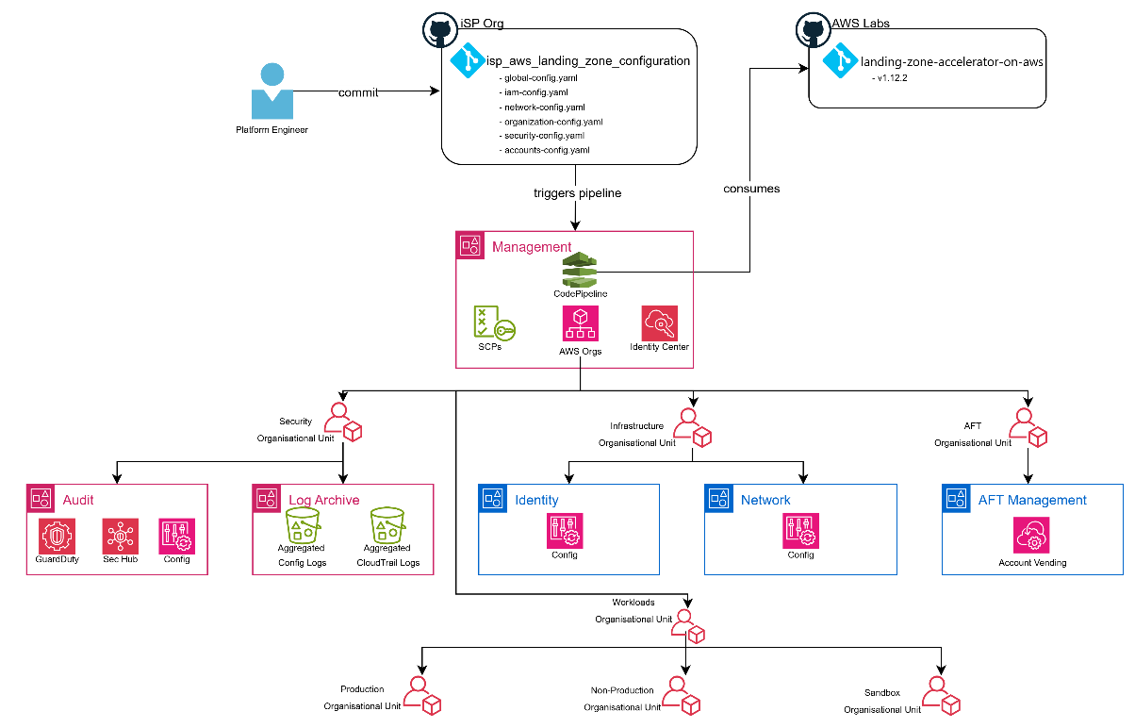
Figure 3 Landing Zone Accelerator - Deployment

Account Factory for Terraform (AFT)
While the AWS Landing Zone Accelerator (LZA) focuses on deploying a comprehensive, compliant multi-account baseline, Account Factory for Terraform (AFT) serves a distinct, complementary purpose.
AFT is an open-source solution built on top of AWS Control Tower that specifically leverages Terraform (HashiCorp’s IaC tool) to automate the provisioning and customisation of individual AWS accounts. Unlike LZA, which establishes the overarching foundational infrastructure and governance of the Landing Zone itself using AWS CDK and YAML configurations, AFT provides a GitOps-driven pipeline for self-service account vending, enabling iSP’s Cloud Platform team to procure new, pre-configured accounts in compliance with established guardrails.
This distinction means the LZA builds the foundation, while AFT provides the automated "factory" to rapidly spin up new accounts within the established foundational structure, offering greater flexibility for teams who prefer Terraform for their infrastructure deployments.
Account Factory for Terraform (AFT) offers distinct advantages beyond merely supporting Terraform-proficient teams:
- AFT mitigates operational risk by separating the provisioning of individual member accounts from the broader landing zone deployment.
- Smaller Blast Radius:
  - The AWS Landing Zone Accelerator (LZA) relies on a highly complex CodePipeline instance to manage the entire multi-account environment. A misconfiguration or issue within the LZA's core pipeline could have a wide-ranging, detrimental impact across the entire AWS Organisation.
  - In contrast, AFT's pipelines are specifically focused on vending and customising individual member accounts. A misconfiguration within an AFT process is scoped primarily to the specific account(s) affected, significantly limiting the potential "blast radius" to individual member accounts rather than the foundational Landing Zone itself.
- AFT provides a more agile and resilient workflow for routine account creation, reducing the need to frequently interact with or re-execute the more complex and comprehensive LZA pipeline for this specific task.

AFT Repositories
Repo Name | GitHub Link
isp_aws_lz_aft_account_request | https://github.com/International-Schools-Partnership/isp_aws_lz_aft_account_request
isp_aws_lz_aft_global_customizations | https://github.com/International-Schools-Partnership/isp_aws_lz_aft_global_customizations
isp_aws_lz_aft_account_  provisioning_customizations | https://github.com/International-Schools-Partnership/isp_aws_lz_aft_account_provisioning_customizations
isp_aws_lz_aft_account_customizations | https://github.com/International-Schools-Partnership/isp_aws_lz_aft_account_customizations
isp_aws_account_factory_vending | https://github.com/International-Schools-Partnership/isp_aws_account_factory_vending

Account Factory for Terraform – Deployment

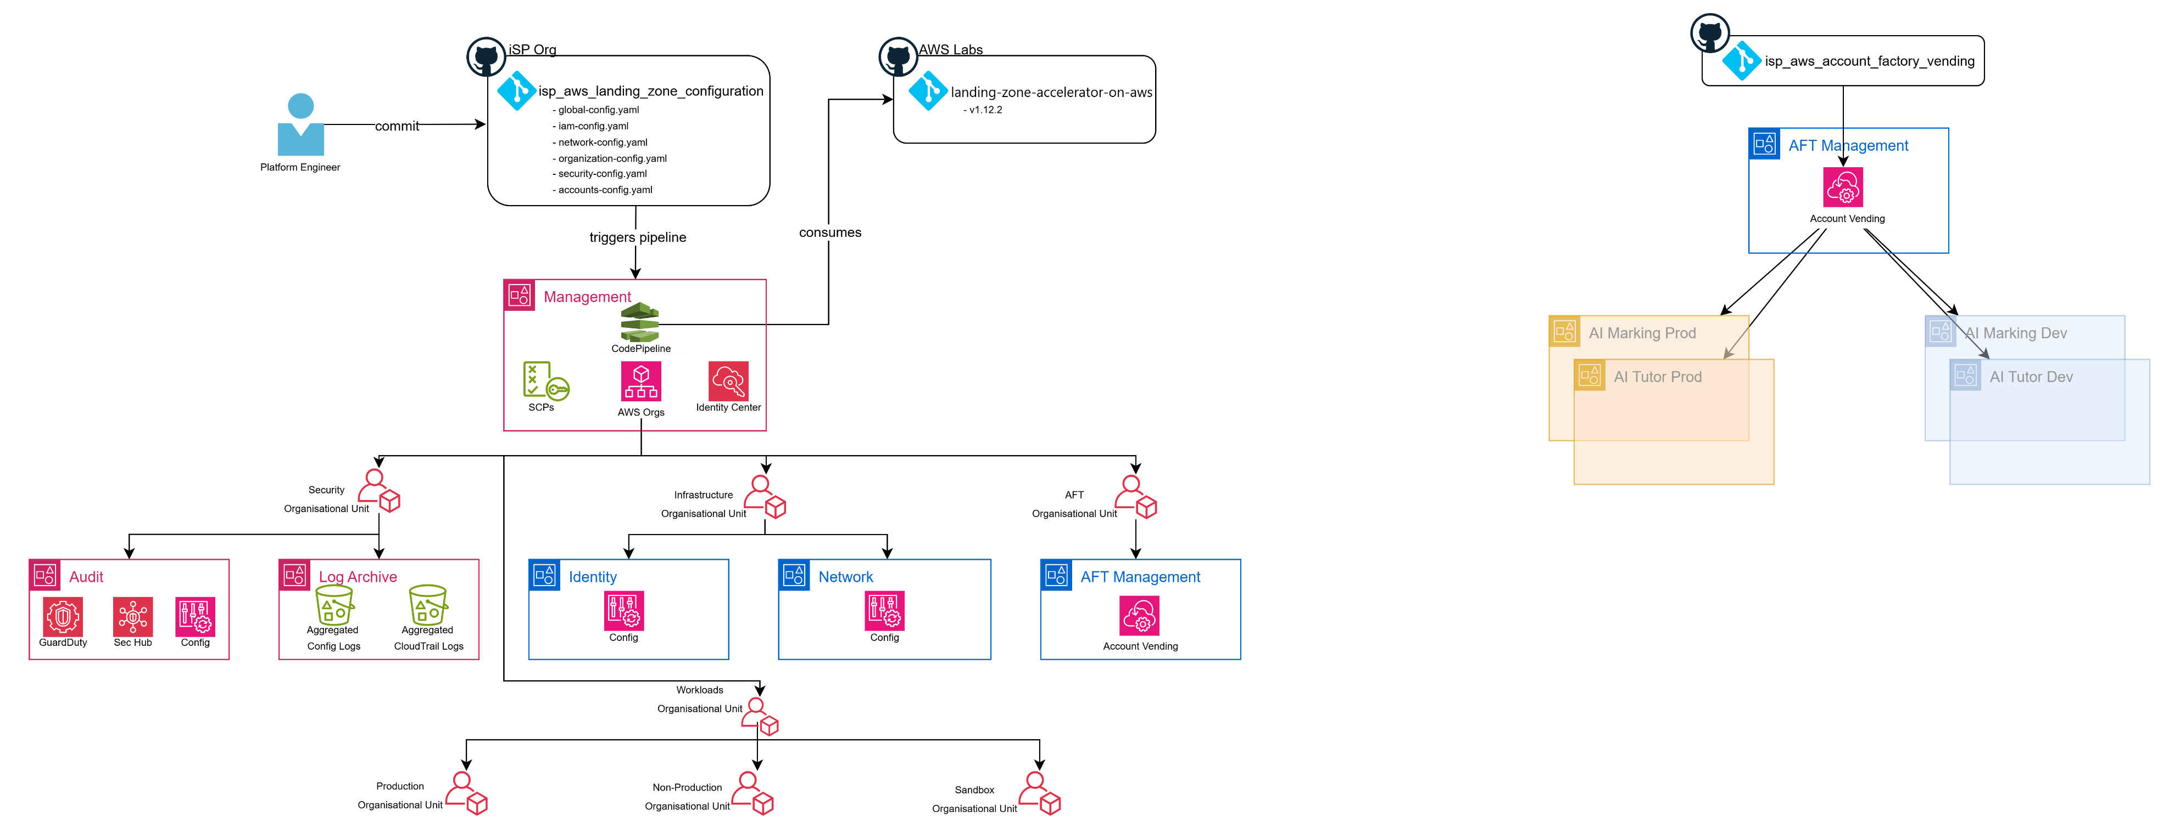
Figure 4 AFT - Deployment

Network Architecture
The following sub-sections capture the high-level network architecture that has been introduced as part of the Landing Zone implementation

Hub & Spoke Topology
To facilitate a centralised egress architecture, a Hub and Spoke network topology will be deployed. A dedicated Hub Virtual Private Cloud (VPC) deployed to the AWS Network account will host various network services and connect to workload specific Spoke VPCs hosted within AWS workload accounts.
The following list describes the network principles as they relate to this Hub & Spoke network topology
- The Hub VPC will be configured with a CIDR range of 10.100.0.0/24 providing eight /27 subnets across two Availability Zones. Since AWS withholds the first four IPs and the broadcast address (e.g. 10.100.0.255) in each subnet, this provides 27 useable IPs per subnet.
- The Network account and its Hub VPC will be dedicated exclusively to networking services (TGW endpoints, AWS Firewall, NAT Gateway), preventing the deployment of application workloads within this security-critical layer.
- The Network account will host a Transit Gateway to facilitate connectivity between Hub and Spoke VPCs, an instance of AWS Network Firewall to govern traffic flows and a NAT Gateway.
- A Transit Gateway deployed to the Network account will attach to both the Hub VPC and multiple Spoke workload VPCs in a 1-to-many manner.
- All egress (outbound) traffic originating from Spoke VPCs will be routed through the network services hosted within the Hub VPC before being routed to the Internet.
- All Spoke VPCs will be configured with a default route (0.0.0.0/0) with a next hop pointing to the Transit Gateway network interface which introduces forced tunneling requiring all internet bound traffic to be inspected.
- The Transit Gateway will route all egress traffic to the AWS Firewall service which will process (and inspect where appropriate) the traffic before forwarding to the NAT Gateway.
- The NAT Gateway provides a consistent public IP for routing all Internet bound traffic.
- Spoke VPC to Spoke VPC traffic will not be permitted unless a specific AWS Firewall policy has been configured.
- Spoke VPCs will not be directly peered or connected.

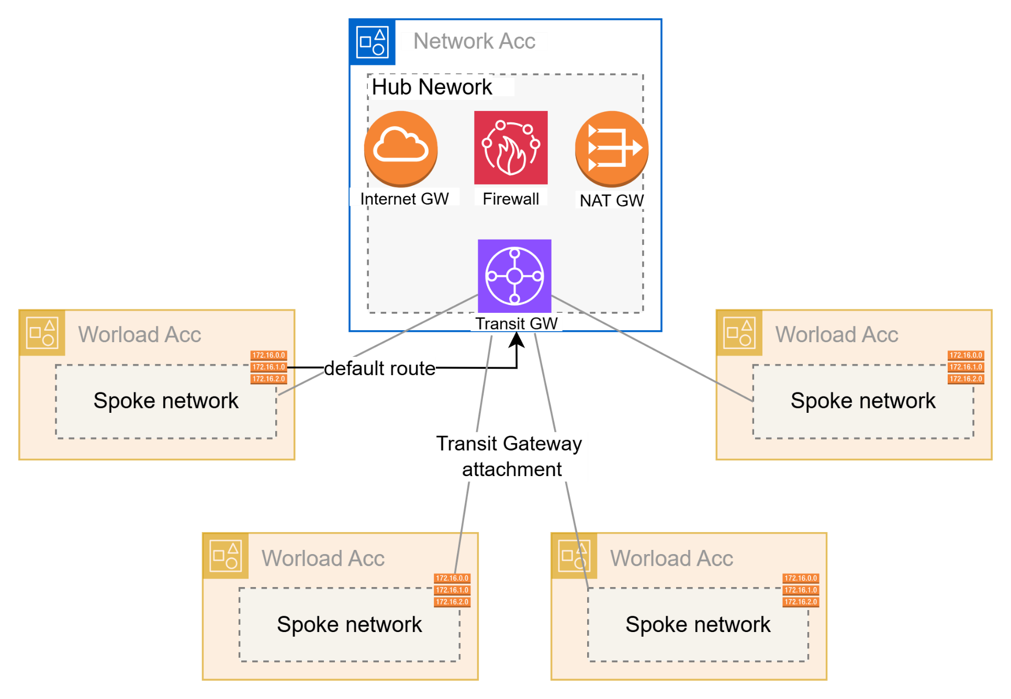
Figure 5 Hub & Spoke topology

Hub Virtual Private Cloud (VPC)
The table below provides a breakdown of the Hub’s Virtual Private Cloud (VPC) from a subnet perspective.
VPC Name | Subnet Name | Subnet CIDR | AZ | Public / Private | Purpose
isp-lz-hub-vpc | isp-lz-hub-vpc/eu-west-2a/nat-gw-subnet | 10.100.0.0/27 | 1 | Public | Hosts NAT Gateway endpoint
isp-lz-hub-vpc | isp-lz-hub-vpc/eu-west-2b/nat-gw-subnet | 10.100.0.32/27 | 2 | Public | Hosts NAT Gateway endpoint
isp-lz-hub-vpc | isp-lz-hub-vpc/eu-west-2a/network-firewall-subnet | 10.100.0.64/27 | 1 | Private | Hosts the AWS Network Firewall
isp-lz-hub-vpc | isp-lz-hub-vpc/eu-west-2b/network-firewall-subnet | 10.100.0.96/27 | 2 | Private | Hosts the AWS Network Firewall
isp-lz-hub-vpc | isp-lz-hub-vpc/eu-west-2a/tgw-subnet | 10.100.0.128/27 | 1 | Private | Hosts the AWS Transit Gateway
isp-lz-hub-vpc | isp-lz-hub-vpc/eu-west-2b/tgw-subnet | 10.100.0.160/27 | 2 | Private | Hosts the AWS Transit Gateway
isp-lz-hub-vpc | TBC | 10.100.0/192/27 | 1 | Private | Reserved for future use.
isp-lz-hub-vpc | TBC | 10.100.0.224/27 | 2 | Private | Reserved for future use.

The diagram below further details the Hub VPC network architecture. Initially, to optimise data transfer costs and align with anticipated low short-term traffic volumes, core network services – specifically the NAT Gateway, Transit Gateway, and Network Firewall – will be deployed within a single Availability Zone (AZ1). As the Landing Zone matures and workload onboarding increases, these critical network services will be seamlessly expanded (by way of IaC) to span two Availability Zones, thereby establishing a highly available and resilient infrastructure capable of withstanding potential disruptions to AZ1.

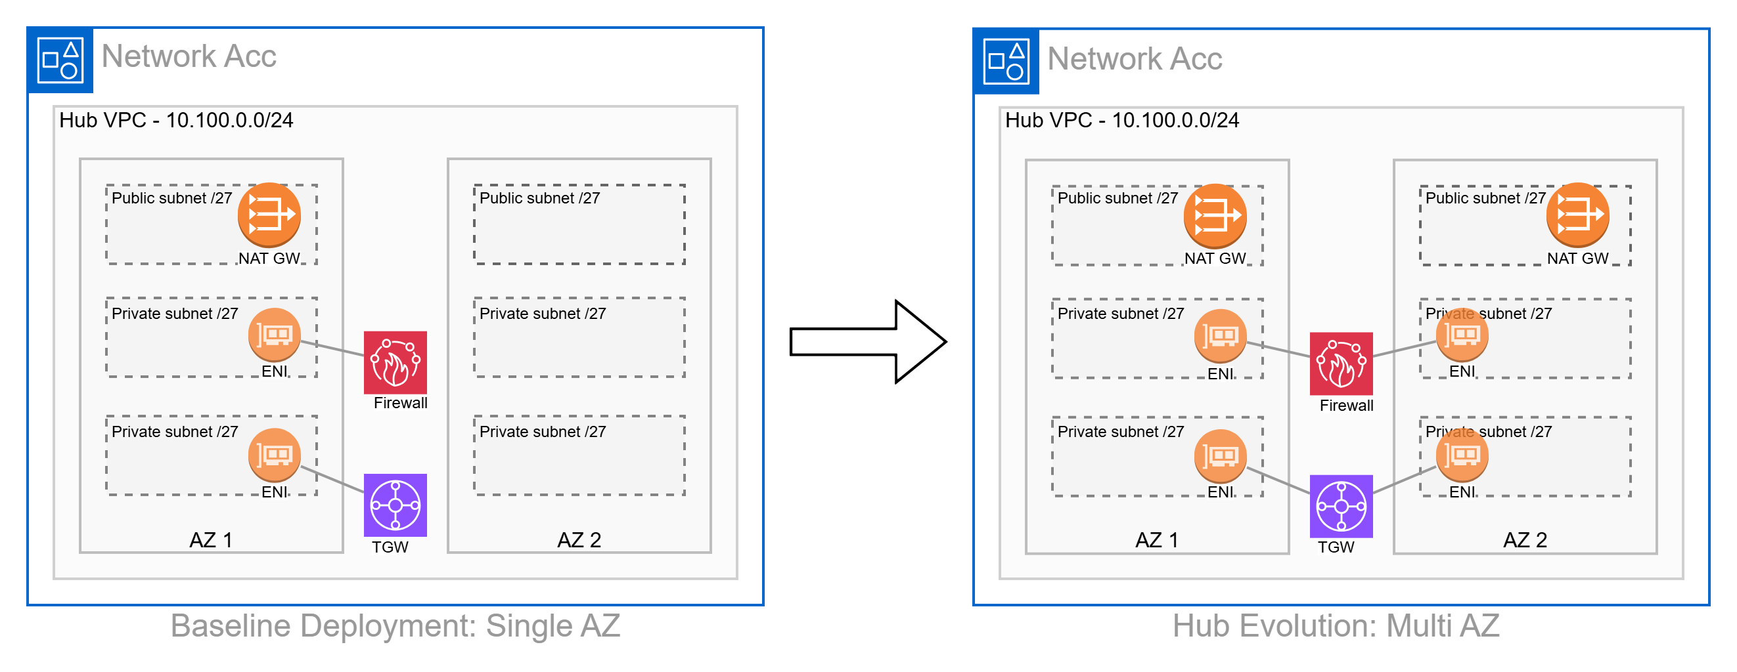
Figure 6 Hub VPC baseline deployment

The figure below illustrates how over time, with increased traffic volumes, the Hub VPC will evolve to span multiple AZs and therefore increase the availability and resiliency of network services.
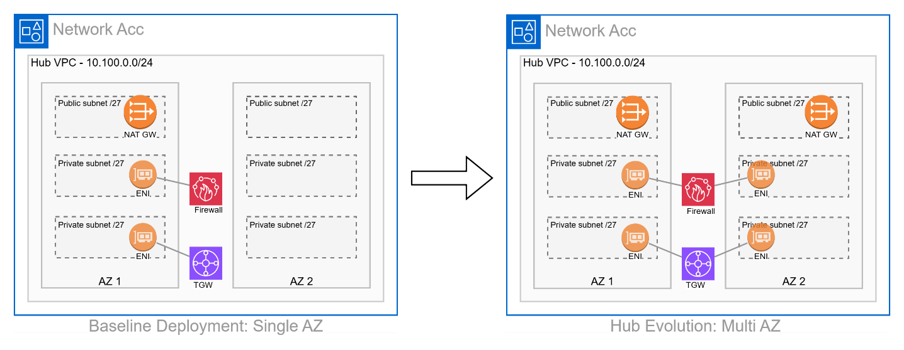
Figure 7 Hub VPC Evolution

Egress Design
As detailed, the Hub VPC will serve as a central point for controlling and inspecting all egress traffic.
The following list captures the network architecture specifically related to the egress design
- Rather than each spoke VPC having its own egress path (e.g., individual NAT Gateways and Internet Gateways), Spoke VPC route tables will direct all internet-bound traffic (0.0.0.0/0) to the Transit Gateway, ensuring all egress flows through a dedicated Hub VPC in the Network account, which acts as the sole internet egress point and control plane
- An AWS Transit Gateway instance deployed to the Network account acts as a central router. Spoke VPCs attach to the Transit Gateway, and the Transit Gateway routes their internet-bound traffic to the Hub VPC.
- The Transit Gateway "Appliance Mode" will be enabled for the attachment to the Hub VPC to ensure symmetric routing, which is crucial for stateful firewalls e.g. AWS Network Firewall, to maintain connection state.
- Egress internet bound traffic will traverse a security inspection layer (AWS Network Firewall) before reaching the internet via the NAT Gateway, ensuring comprehensive traffic filtering and threat detection.
- All internet-bound traffic from Spoke VPCs will exit through the static public IP address(es) of the centralised NAT Gateway (deployed to the Network account), providing a consistent and auditable source for external services.
- All relevant logs (Firewall, NAT Gateway, VPC Flow Logs from Hub) will be aggregated to the central logging account – Log Archive account - for comprehensive egress traffic visibility.

Ingress Design

The Landing Zone environment will adopt a decentralised/distributed ingress architecture to ensure optimal performance, security, and operational autonomy for individual workloads.
- Each backend workload and application will be responsible for creating and managing its own dedicated ingress infrastructure required to expose its web application frontend or API. This ensures tight coupling of ingress resources to the application stack, aligning with the principle of distributed ownership. This principle also aligns with the current configuration of the AI Toolbox and AI Marking stacks.
- Individual workloads will utilise the most suitable AWS ingress service for their specific needs, such as:
  - Amazon CloudFront Distributions for web applications with a globally distributed user base, particularly those with React frontends hosted on Amazon S3 buckets. This common reference architecture will be supported by direct CloudFront-to-S3 origin configurations.
  - Application Load Balancers (ALBs) for more complex web applications or APIs requiring Layer 7 routing.
  - Amazon API Gateway for RESTful or WebSocket APIs.
- As a core security guardrail within the AWS Landing Zone, all deployed Application Load Balancers (ALBs) and CloudFront Distributions must have an AWS WAF Access Control List (ACL) configured and associated. Resources deployed without a WAF will be flagged as non-compliant by the Landing Zone guardrails. This ensures comprehensive protection against common web exploits and malicious traffic.
- All internet-accessible workloads will be deployed within private subnets, with public subnets reserved exclusively for load balancing (e.g., ALBs, CloudFront Distributions). This pattern ensures that application instances are not directly exposed to the internet, enhancing the overall security posture.
- While ingress is distributed, security configurations for AWS WAF will be centrally administered and maintained through AWS Firewall Manager. This provides consistent security policy enforcement across all accounts and ingress points.


The specific ingress resources required to support an application will be determined as workloads are onboarded to the Landing Zone. No ingress resources will be deployed as part of the Landing Zone build.

Ingress & Egress Traffic Flows
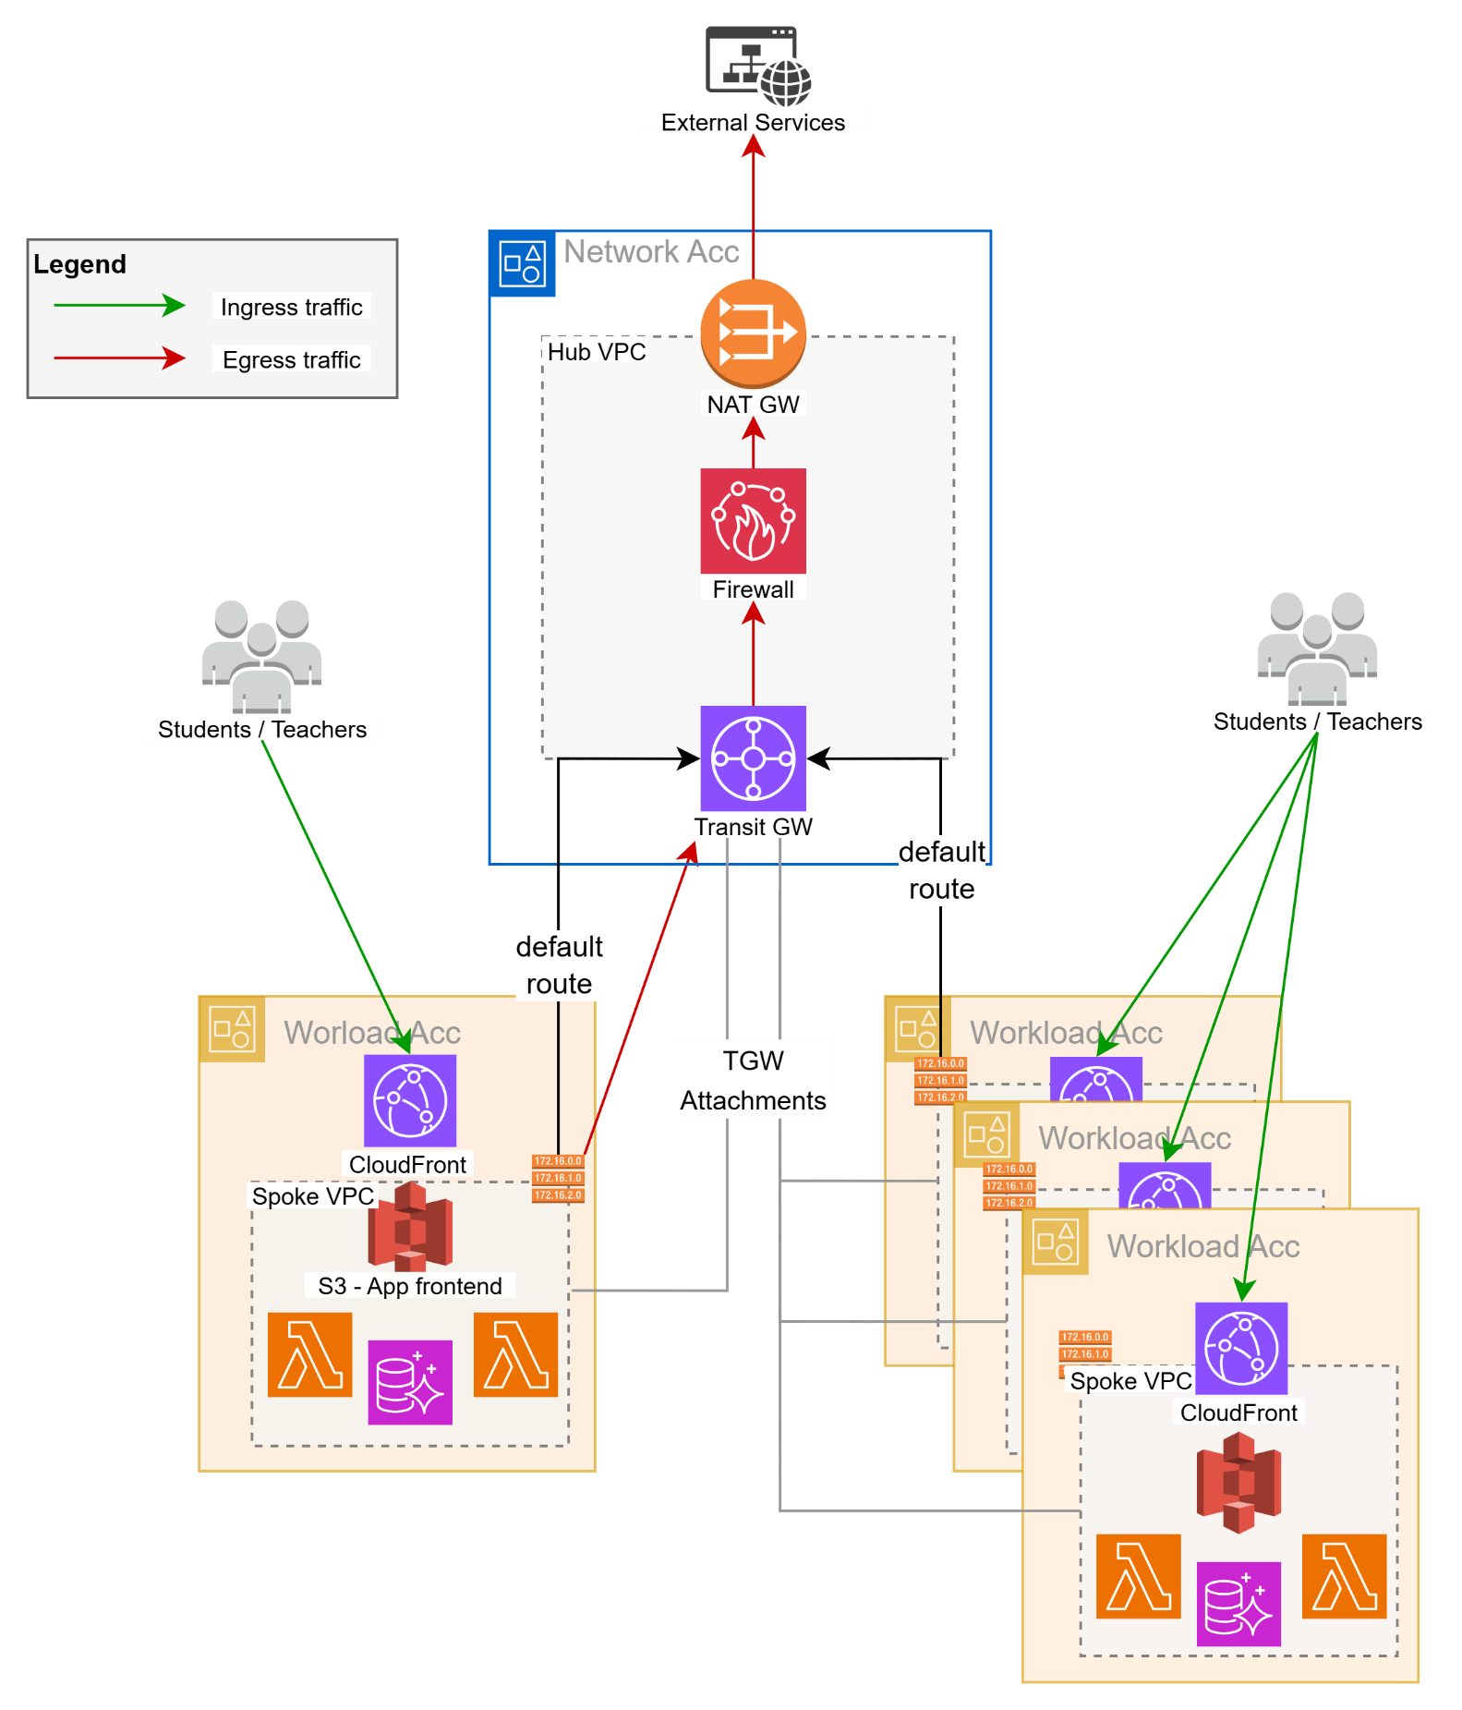

Figure 8 Ingress & Egress Traffic flows

Security

IAM Identity Center

IAM Identity Center (formerly AWS Single Sign-On) will be leveraged to provide a streamlined and secure method for managing access across the multi-account AWS environment.
- The Landing Zone Accelerator creates an IAM Identity Center instance in the AWS Management account. This service facilitates Single-Sign On for all AWS users which is especially pertinent when working in a multi-account structure. The introduction of this service negates the need to create and manage separate IAM users in each individual account, significantly reducing administrative overhead.
- It facilitates a seamless Single Sign-On experience for all AWS users. Users log in once to a central user portal with their credentials and can then securely access all assigned AWS accounts and roles without re-authenticating.
- When new users are created an invitation process guides them through password setup and mandatory Multi-Factor Authentication (MFA) configuration. This ensures a standardised, secure, and automated onboarding experience. Conversely, centralised management simplifies rapid offboarding and access revocation.
- Access to AWS accounts is managed through Permission Sets. These define specific AWS IAM policies and permissions (e.g., Administrator Access, Read-Only, Developer Access) that are then assigned to users or groups. IAM Identity Center automatically provisions and manages corresponding IAM roles in each target AWS account, ensuring consistent application of the principle of least privilege across your organisation.
- The management of new identities, existing identities and associated permissions is all managed under IAM Identity Center console.


For the initial Landing Zone implementation, IAM Identity Center will be configured to provide Single Sign-On (SSO) capabilities across all member accounts within the AWS Organisation, with users managed directly within Identity Center's own directory. The primary purpose at this stage is to centralise user access and streamline login to AWS accounts. This baseline configuration does not include integration with external Identity Providers (IdP) or the development of custom IAM roles via Identity Center.

SSO Login Page
The table below captures the SSO login page for accessing the various AWS accounts deployed as part of the Landing Zone.

Description | Link
iSP AWS LZ SSO Landing Page | https://d-9c6756350e.awsapps.com/start

Root Identities

When a new AWS account is created, whether it's a standalone account or part of an AWS Organisation, a unique root user identity tied to an email address is a mandatory requirement to complete the process. For iSP’s AWS Landing Zone, all of the core Platform AWS accounts will leverage the "plus addressing" feature of the Management account's email address. This strategy ensures that the root user email for every core Platform AWS account adheres to a consistent and easily identifiable naming convention: <management_account_email>+<AWS_Account Name>@ispschools.com. For example, since the Management account's email is ispawslz@ispschools.com, the root user email associated with the Landing Zone’s Network account is ispawslz+network@ispschools.com. Similarly, the root user email associated with the Log Archive AWS account is ispawslz+logarchive@ispschools.com.
This method offers several benefits for managing a multi-account AWS environment:
- All root user emails for various accounts route to a single, controlled inbox associated with the Management account. This simplifies monitoring and significantly reduces the administrative overhead of managing separate mailboxes for each account.
- By centralising email reception, it becomes easier to secure the primary email inbox, thereby safeguarding the recovery mechanism for all root users across the organisation. This reduces the attack surface compared to scattering root user emails across multiple, potentially less secure, individual mailboxes.
- In the event of a lost root user password or compromised credentials for any member account, the password reset emails are delivered to the designated Management account inbox, facilitating a quicker and more controlled recovery process.
- Having a consistent and predictable naming pattern for root user emails aids in auditing and tracking account ownership and communication.


For all workload AWS accounts deployed to the Landing Zone, a new Shared mailbox will be generated to mitigate against any security compromises relating to the Shared mailbox configured on the Platform level AWS accounts i.e. ispawslz@ispschools.com, providing a layer of demarcation between workload and Platform level AWS accounts.

For AWS accounts deployed via the Platform config repository e.g. Network account, Audit account:
- An SSO Identity is automatically generated for each account, except for the Audit and LogArchive accounts. These two accounts only have a root user email address; they do not get an SSO identity.
For AWS accounts deployed via the Account Factory for Terraform (AFT) managed repository:
- Both a root user identity and an SSO root user identity are generated.
- This dual identity approach significantly enhances security by minimizing direct root user logins. Instead, users can access the new AWS account via an automatically generated IAM Identity Center user, which aligns with AWS best practices. This automated creation streamlines access, saves time, and provides the flexibility for distinct email addresses for the root and SSO users.
AWS Account | Root User Identity | SSO Identity
Management | ispawslz@ispschools.com | ispawslz@ispschools.com
Audit | ispawslz+audit@ispschools.com | N/A
Log Archive | ispawslz+logarchive@ispschools.com | N/A
Network | ispawslz+networking@ispschools.com | ispawslz+networking@ispschools.com
Identity | ispawslz+identity@ispschools.com | ispawslz+identity@ispschools.com
AFT Management | ispawslz+aft@ispschools.com | ispawslz+aft@ispschools.com
EdTech AI Marking Test | edtech-ai-marking-test@ispschools.com | edtech-ai-marking-test@ispschools.com
EdTech AI Marking Production | edtech-ai-marking-production@ispschools.com | edtech-ai-marking-production@ispschools.com
EdTech AI Tutor Test | edtech-ai-tutor-test@ispschools.com | edtech-ai-tutor-test@ispschools.com
EdTech AI Tutor Production | edtech-ai-tutor-production@ispschools.com | edtech-ai-tutor-production@ispschools.com
EdTech AI Sandbox | edtech-ai-sandbox@ispschools.com | edtech-ai-sandbox@ispschools.com
AWS Infrastructure Sandbox | aws-infra-sandbox@ispschools.com | aws-infra-sandbox@ispschools.com

Securing Root Identities
While the root user of each AWS account in the Landing Zone should be used sparingly, securing the root email address and its associated identity is crucial for maintaining the overall security posture and ensuring a recovery mechanism for the multi-account environment. This email address serves as the primary recovery point for the account's root user credentials, making its compromise a critical threat that could lead to unauthorised access and control over AWS resources.
To achieve robust security for these critical root email identities, a standard process should be rigorously followed for each new account provisioned within the Landing Zone:
- Accept invitation: Upon account creation and its invitation to the AWS Organisation, the root user associated with the unique email must accept the invitation. This involves a first-time login to the AWS Management Console for that specific account e.g. ispawslz+network@ispschools.com
- Initial login: After the initial login, the default or temporary password must be immediately changed to a strong, complex, and unique password. This new password should never be shared verbally or stored insecurely.
- Securely store password: The new password for each account's root user must be stored securely in an enterprise-grade password manager.
- MFA: Multiple MFA devices (e.g., multiple virtual MFA applications on different trusted individuals' phones) should be registered to each root user. This redundancy ensures that if one device is lost or inaccessible, there are still alternative authorised MFA devices to regain access.
- Shared Mailbox: The use of "plus addressing" (e.g., ispawslz+network@ispschools.com) routes all root user emails to a designated, shared mailbox (i.e., ispawslz@ispschools.com). This centralises the receipt of critical notifications for all accounts.
- Forwarding Rules: (Optional, but recommended) To mitigate the risk of important emails being lost or unread in a shared mailbox that might not be frequently checked, configure automated forwarding rules. These rules should forward all incoming emails from the root email addresses to a distribution list of relevant administrators (e.g., a DL containing Vik, Matt, Craig & Stuart) or integrate with a centralised alerting system (e.g., Microsoft Teams). This ensures that critical alerts are pushed to the relevant personnel's personal inboxes or collaborative channels, requiring no explicit action to "check" the shared mailbox and dramatically reducing the chance of missing vital communications.

AWS Web Application Firewall
The AWS Web Application Firewall (WAF) service operates at Layer 7 of the OSI model and will primarily be used to introduce a layer of security on publicly exposed ingress infrastructure e.g. CloudFront Distributions and Application Load Balancers.
The list below provides a non-exhaustive list of the service’s key functions:
- pre-configured rule groups provided by AWS to protect against common threats e.g. OWASP Top 10 vulnerabilities (SQL injection, XSS, etc.), known bad IPs, common bot attacks, and specific vulnerability exploits.
- custom rules based on IP addresses, HTTP headers, HTTP body, URI strings, query strings, HTTP methods, and size constraints.
- regular expressions for more flexible pattern matching in requests.
- managed rule group specifically designed to detect and block common and egregious bots (e.g., scanners, crawlers, spammers) while allowing legitimate ones.
- metrics and dashboards in Amazon CloudWatch for monitoring traffic patterns and blocked requests.


The initial Landing Zone implementation does not necessitate the deployment of CloudFront Distributions or Application Load Balancers, as a distributed ingress architecture has been adopted. Therefore, the specific configurations of AWS WAF will only be considered and implemented as individual workloads are onboarded to the Landing Zone and their respective ingress requirements are evaluated.

AWS Network Firewall
The AWS Network Firewall service operates at Layer 3 & 4 of the OSI model for stateless and stateful inspection based on IP addresses, ports, and protocols. It also has Layer 7 awareness by way of Fully Qualified Domain Name (FQDN) filtering and Server Name Indication (SNI) inspection within encrypted traffic. The service will be deployed to the centralised Hub VPC within the Network account to govern egress traffic only.
The list below provides a non-exhaustive list of the service’s key functions:
- monitors the state of connections (TCP, UDP, ICMP) and makes decisions based on the entire flow, not just individual packets. This is crucial for allowing return traffic of an established connection.
- supports session-based filtering and anomaly detection.
- allows/blocks traffic to specific Fully Qualified Domain Names (FQDNs).
- deployed in the Hub VPC as a firewall endpoint in dedicated subnets per AZ.
- integrates seamlessly with AWS Transit Gateway for centralised inspection of traffic from multiple VPCs (egress and inter-VPC traffic).
- Metrics and dashboards available under Amazon CloudWatch

For the initial Landing Zone implementation, the AWS Network Firewall will be configured with a default deny-all egress policy. This proactive security posture will remain in effect until specific workload requirements necessitate the creation of explicit egress rules upon onboarding to a Spoke account/VPC.

AWS Security Hub
Within the AWS Landing Zone, Security Hub plays a critical central role in establishing and maintaining a robust security posture:
- Aggregates security findings from various AWS security services e.g., GuardDuty, Config
- By default, Security Hub will automatically check the AWS Landing Zone environment against a set of security best practices, providing actionable insights into misconfigurations and potential vulnerabilities.
- Offers a comprehensive, high-level view of your security posture across all linked accounts in your AWS Organisation.
- Security Hub is configured in the Audit Account within the AWS Landing Zone's multi-account structure. This account serves as the delegated administrator for Security Hub within AWS Organisations.
- Security Hub is configured to aggregate security findings from all member accounts in the AWS Organisation into this central Audit Account. This provides security teams with a single pane of glass for all security-related events and compliance status across the entire enterprise.
- The service facilitates the configuration of many industry recognised frameworks (e.g., CIS Benchmark) which, once enabled, automatically checks if resources deployed by development teams in spoke accounts adhere to established security guardrails.
- Centralising the Security Hub to the Audit account reduces the operational burden on individual account owners allowing them to focus on core application development while security is enforced consistently from the Landing Zone's security foundation.


For the initial Landing Zone implementation, AWS Security Hub will be configured to automatically enable and aggregate findings from all newly provisioned member accounts within the AWS Organisation. The AWS Foundational Security Best Practices (FSBP) standard will be activated by default to provide continuous security posture monitoring from day one. Further security standards (e.g., CIS AWS Foundations Benchmark, PCI DSS), custom insights, and automated remediation actions will be progressively assessed and configured as workloads are onboarded, and specific compliance and operational security requirements evolve.

AWS Foundational Security Best Practices v1.0.0
Developed by AWS and industry professionals, the AWS Foundational Security Best Practices (FSBP) standard is a compilation of security best practices for organisations, regardless of organisation sector or sise. It provides a set of controls that detect when AWS accounts and resources deviate from security best practices. It also provides prescriptive guidance about how to improve and maintain your organisation's security posture.
In AWS Security Hub Cloud Security Posture Management (CSPM), the AWS Foundational Security Best Practices standard includes controls that continuously evaluate your AWS accounts and workloads, and help you identify areas that deviate from security best practices. Further detail regarding the security controls introduced as part of this framework are detailed here.

Following the Landing Zone implementation, iSP will need to adopt a process to continuously evaluate the Landing Zone’s security posture score and develop a mechanism to address critical security notifications.

AWS Cognito
The AI Toolbox application currently leverages AWS Cognito User Pools to manage federated identities, integrating with OneLogin as its centralised Identity Provider (IdP). As of now, a critical project is underway to transition this IdP integration from OneLogin to ClassLink.
It's important to note that the existing Cognito pools for the AI Toolbox are deployed within a dedicated, isolated AWS account, which operates independently of the broader AWS Landing Zone environment described in this document.


Our current understanding is that all future AI-based applications are intended to integrate with ClassLink for centralised identity management. However, a crucial architectural decision is pending regarding the optimal hosting strategy for AWS Cognito User Pools within AWS. At a high level, two primary deployment models are available:
- Centralised Cognito Pools: This approach proposes the deployment of all Cognito pools within a dedicated AWS Identity account. These pools would be governed and operated by a central Cloud Platform team. This approach offers the significant advantage of providing all applications with a consistent and predictable interface for identity and access management.
- Distributed Cognito Pools: Alternatively, this approach proposes that Cognito pools be deployed directly into their respective application and environment-specific AWS accounts. With this approach, the application development teams would retain full operational autonomy over the creation, management, and security of their individual Cognito pools. This approach aligns with the distributed ingress architecture described above, where development teams have a high degree of control over their application's infrastructure.

Account Governance

Platform Baseline Configuration
The six core configuration files of the AWS Landing Zone Accelerator (LZA) solution work together to establish an automated platform-level baseline for the AWS environment. By abstracting complex infrastructure and security configurations into structured YAML definitions, these files collectively define the multi-account AWS Organisation structure, centralised identity and access management, foundational security services, and global operational settings.

Global Config
The table below describes the configurations defined under the global-config.yaml file version controlled under isp_aws_landing_zone_configuration repository.
This file manages global properties that apply across the entire AWS Organisation. This includes settings for AWS Control Tower integration, backup vaults, AWS Budgets, CloudTrail configurations, S3 encryption, SNS topics, and general tags to be applied to LZA-created resources. It sets the overarching parameters for the landing zone.

Policy | Description | Scope | Value
Regions | Defines the primary "home" region and other regions where LZA components and governance are active. Opt-in regions are not automatically enabled. | Organisation-wide | homeRegion: eu-west-2, enabledRegions: [eu-west-2], enableOptInRegions: false
Management Account Access Role | Specifies the IAM role that AWS Control Tower uses for cross-account access and management. | Management Account (provides access to all member accounts) | AWSControlTowerExecution
Default Event Bus | Configures a central Amazon EventBridge event bus with a defined policy, allowing for centralised event routing across the organisation. | All Accounts (under Root OU) | policy: event-bus-policies/eventbus-policy.json, deploymentTargets: Root
CloudWatch Log Retention | Sets a long retention period for all CloudWatch Log Groups managed by LZA. | All Accounts (all LZA-managed Log Groups) | 3653 days (approx. 10 years)
CDK Options | Global parameters influencing LZA's CDK deployment, such as centralising S3 buckets for logging and utilising the Management Access Role. | Global Deployment Parameters | centraliseBuckets: true, useManagementAccessRole: true
Termination Protection | Enables CloudFormation stack termination protection for core LZA-deployed stacks to prevent accidental deletion of foundational infrastructure. | LZA Foundational Stacks (Organisation-wide) | TRUE
SNS Topics | Creates an organisation-wide "Security" SNS topic with a specified email address for critical notifications and alerts. | All Accounts (under Root OU) | name: Security, emailAddresses: ispawslz+security@ispschools.com, deploymentTargets: Root
Control Tower Integration | Enables and specifies the version of AWS Control Tower for the landing zone. Configures Control Tower's logging retention for central S3 buckets and enables IAM Identity Center. | Control Tower Deployment (Organisation-wide) | enable: true,  version: 3.3, loggingBucketRetentionDays: 365, accessLoggingBucketRetentionDays: 3650, enableIdentityCenterAccess: true
Centralised Logging | Designates the LogArchive account for central logging. Configures a multi-region, organisation-level CloudTrail to capture API events from all accounts, sending logs to S3 and CloudWatch. Includes S3 lifecycle rules for log storage. | Organisation-wide (with logs stored in Log Archive account) | account: LogArchive, organisationTrail: true, multiRegionTrail: true, globalServiceEvents: true, managementEvents: true, s3DataEvents: true, lambdaDataEvents: true, sendToCloudWatchLogs: true, AccountTrail in eu-west-2, S3 lifecycleRules (1000 days expiration, 365 days to GLACIER_IR)
Session Manager Logging | Configures AWS Systems Manager Session Manager to send session logs to both CloudWatch Logs and S3, with defined lifecycle rules for S3. | All Accounts (unless excluded) | sendToCloudWatchLogs: true, sendToS3: true, S3 lifecycleRules (1000 days expiration, 365 days to GLACIER_IR)
CloudWatch Logs Data Protection | Implements data protection policies in CloudWatch Logs to detect and redact sensitive data (e.g., credentials) from log streams. | All Accounts (relevant Log Groups) | managedDataIdentifiers: Categories: Credentials
S3 Log Bucket Lifecycles | Defines lifecycle rules for various centralised S3 log buckets (access logs, central logs, ELB logs) for cost optimisation. | Log Archive Account (specific S3 buckets) | abortIncompleteMultipartUpload: 7, expiration: 1000, noncurrentVersionExpiration: 1000, transitions: GLACIER_IR after 365 for accessLogBucket, centralLogBucket, elbLogBucket
Cost & Usage Report (CUR) | Configures a daily AWS Cost and Usage Report (CUR) at the organisation level, in Parquet format, including comprehensive cost details, with lifecycle rules for retention. | Organisation Level | compression: Parquet, format: Parquet, reportName: accelerator-cur, timeUnit: DAILY, refreshClosedReports: true, reportVersioning: CREATE_NEW_REPORT, expiration: 730 days, noncurrentVersionExpiration: 730 days
Budgets | Defines a specific monthly cost budget for the Management account with detailed email notification thresholds. | Management Account | name: lz-budget, timeUnit: MONTHLY, type: COST, amount: 2000 USD, notifications at 50%, 75%, 80%, 90%, 100% to ispawslz+budgetnotifications@ispschools.com
Backup Vaults | Deploys a central AWS Backup Vault named "BackupVault" to all accounts, providing a centralised repository for managed backups. | All Accounts (under Root OU) | name: BackupVault, deploymentTargets: Root

Organisation Config
This file manages organisational-level settings within AWS Organisations. Here, you define Organisational Units (OUs), Service Control Policies (SCPs) to govern permissions at the OU level, and policies related to tagging and backups that can be applied across the organisation.
The table below describes the configurations defined under the organisation-config.yaml file version controlled under isp_aws_landing_zone_configuration repository.

Policy | Description | Scope | Value
Enable Organisation Deployment | Controls whether the AWS Organisation management features are enabled and deployed by the Landing Zone Accelerator. | LZA Deployment (Global) | TRUE
Organisational Units (OUs) | Defines the logical structure of your AWS Organisation by specifying the names of Organisational Units to be created. This includes nested OUs for workloads and a dedicated OU for suspended accounts. | AWS Organisation Structure (Parent OU for each defined) | Security, Infrastructure, Workloads, Workloads/Production, Workloads/Non-Production, Workloads/Sandbox, AFT-Management, SuspendedAccounts
Quarantine New Accounts | Enables a feature that automatically places newly created accounts into a quarantine state, applying a specific Service Control Policy (SCP) to restrict actions until the LZA has successfully configured them. | New Accounts (upon creation) | enable: true, scpPolicyName: Quarantine
Service Control Policies (SCPs) | Defines customer-managed Service Control Policies (SCPs) that restrict permissions across accounts. This includes core "Accelerator Guardrails" and a "Quarantine" policy for new accounts. | Specific Organisational Units (OUs) or All Accounts (for Quarantine) | AcceleratorGuardrails1 (applied to Infrastructure, Security, Workloads, AFT-Management OUs), AcceleratorGuardrails2 (applied to Infrastructure, Security, Workloads, AFT-Management OUs), Quarantine (applied upon new account creation)
Tagging Policies | (Commented out in this config) Would define organisation-wide tagging policies to enforce consistent tagging of AWS resources for governance and cost allocation. | (Currently not deployed) (If enabled, typically Root OU or specific OUs) | [] (empty, i.e. not enabled)
Chatbot Policies | (Empty in this config) Would typically define policies related to AWS Chatbot integrations for notifications. | (Currently not deployed) (If enabled, various scopes) | [] (empty, i.e. not enabled)
Backup Policies | (Commented out in this config) Would define organisation-wide backup policies for AWS Backup. | (Currently not deployed) (If enabled, typically Root OU or specific OUs) | [] (empty, i.e. not enabled)

Accounts Config
The table below describes the configurations defined under the accounts-config.yaml file version controlled under isp_aws_landing_zone_configuration repository.

Account Name | Description | OU | Email
Management | The management (primary) account. | Root | ispawslz@ispschools.com
LogArchive | The log archive account. | Security | ispawslz+logs@ispschools.com
Audit | The security audit account. | Security | ispawslz+audit@ispschools.com
Network | The Network account | Infrastructure | ispawslz+networking@ispschools.com
Identity | The Identity account | Infrastructure | ispawslz+identity@ispschools.com
AFT | The Account Factory for Terraform account | AFT-Management | ispawslz+aft@ispschools.com
edtech-ai-marking-test | The iSP EdTech AI Marking Test account | Workloads/Non-Production | edtech-ai-marking-test@ispschools.com

IAM Config
The table below describes the configurations defined under the iam-config.yaml file version controlled under isp_aws_landing_zone_configuration repository.
Policy | Description | Scope | Value
Policy Sets | (Empty) Would define customer-managed IAM policies to be deployed and attached to roles or users, providing granular permissions. | (Currently not deployed) | [] (empty, i.e. not enabled)
Role Sets | Defines a collection of IAM roles that are deployed across the specified organisational units. These roles are essential for AWS services to perform actions within your accounts. | All Accounts (under Root OU)
Backup-Role | Creates an IAM role (Backup-Role) for AWS Backup service. This role is assumed by backup.amazonaws.com and granted necessary permissions (via AWSBackupServiceRolePolicyForBackup and AWSBackupServiceRolePolicyForRestores managed policies) to perform backup and restore operations. | All Accounts (under Root OU) | name: Backup-Role, assumedBy: backup.amazonaws.com, policies: AWSBackupServiceRolePolicyForBackup, AWSBackupServiceRolePolicyForRestores
Budgets-Role | Creates an IAM role (Budgets-Role) for AWS Budgets service. This role is assumed by budgets.amazonaws.com and granted permissions (via AWSBudgetsActionsWithAWSResourceControlAccess managed policy) to manage budget actions. | All Accounts (under Root OU) | name: Budgets-Role, assumedBy: budgets.amazonaws.com, policies: AWSBudgetsActionsWithAWSResourceControlAccess
Group Sets | (Empty) Would define IAM groups and their associated permissions to manage collections of users. | (Currently not deployed) | [] (empty, i.e. not enabled)
User Sets | (Empty) Would define IAM users and their associated permissions within specific accounts. | (Currently not deployed) | [] (empty, i.e. not enabled)

Network Config

The table below describes the configurations defined under the network-config.yaml file version controlled under isp_aws_landing_zone_configuration repository.

Policy | Description | Scope | Value
Home Region | Defines the primary region for network deployments and where core network resources will be managed from. | Global Deployment Parameter | eu-west-2
Default VPC Management | Specifies whether the default VPC in newly created accounts should be deleted. This is a security best practice to ensure network architecture is explicit and controlled. | All Accounts (unless excluded) | delete: true, excludeAccounts: []
Transit Gateways | (Empty in this config) Would define the deployment and configuration of AWS Transit Gateways for centralised network connectivity between VPCs and on-premises networks across multiple accounts and regions. | (Currently not deployed) (If enabled, typically Transit Gateway account, connected to specific VPCs) | [] (empty, i.e. not enabled)
VPC Endpoint Policies | Defines re-usable JSON policy documents for AWS VPC Endpoints, controlling access to AWS services from within VPCs without traversing the public internet. | Specific VPC Endpoints (when deployed) | Default (using vpc-endpoint-policies/default.json), Ec2 (using vpc-endpoint-policies/ec2.json)
VPCs | (Empty in this config) Would define the creation and configuration of custom Virtual Private Clouds (VPCs), including their CIDR blocks, subnets, and other network components across different accounts and OUs. | (Currently not deployed) (If enabled, specific accounts/OUs) | [] (empty, i.e. not enabled)

Security Config

This file focuses on configuring various AWS security services across the Landing Zone. It allows you to enable and configure services such as AWS Audit Manager, Amazon CloudWatch, AWS Config (including managed rules), AWS Security Hub, Amazon GuardDuty, and other security-related settings.
The table below describes the configurations defined under the security-config.yaml file version controlled under isp_aws_landing_zone_configuration repository.

Policy | Description | Scope | Value
Central Security Services - Delegated Admin Account | Designates the Audit account as the delegated administrator for central security services, allowing centralised management of security tools. | Organisation-wide (via Audit account) | Audit
EBS Default Volume Encryption | Enforces encryption by default for all new EBS volumes created in the specified regions. | All Accounts (across all regions except excluded) | enable: true, excludeRegions: []
S3 Public Access Block | Enforces best practices by blocking public access to newly created and existing S3 buckets across the organisation. | All Accounts (unless explicitly excluded) | enable: true, excludeAccounts: []
SCP Revert Changes Configuration | Automatically reverts unauthorised changes to Service Control Policies (SCPs) and sends notifications to the "Security" SNS topic. | Organisation-wide (on SCPs) | enable: true, snsTopicName: Security
Macie | Enables Amazon Macie for data discovery and sensitive data protection, configuring it to publish findings every fifteen minutes. | All Accounts (unless excluded regions) | enable: true, excludeRegions: [], policyFindingsPublishingFrequency: FIFTEEN_MINUTES, publishSensitiveDataFindings: true
GuardDuty | Enables Amazon GuardDuty for intelligent threat detection and continuous monitoring. Includes S3 Protection and exports findings to an S3 bucket every fifteen minutes. | All Accounts (unless excluded regions) | enable: true, excludeRegions: [], s3Protection: enable: true, exportConfiguration: enable: true, destinationType: S3, exportFrequency: FIFTEEN_MINUTES
Audit Manager | Enables AWS Audit Manager for automated evidence collection to simplify audits. Configures default reports to be stored in S3 with defined lifecycle rules for retention. | All Accounts (unless excluded regions) | enable: true, excludeRegions: [], defaultReportsConfiguration: enable: true, destinationType: S3, S3 lifecycleRules (1000 days expiration, 7 days abort multipart)
Detective | (Disabled) Would enable Amazon Detective for security investigation and analysis of potential security issues. | (Currently Disabled) | enable: false
Security Hub | Enables AWS Security Hub for comprehensive security posture management, centralising security findings and enabling regional aggregation. The "AWS Foundational Security Best Practices v1.0.0" standard is enabled by default. | All Accounts (unless excluded regions), Aggregated to a single region | enable: true, regionAggregation: true, excludeRegions: [], standards: AWS Foundational Security Best Practices v1.0.0 (enabled)
SSM Automation | (Empty) Would define AWS Systems Manager Automation documents for security-related automated responses. | (Currently not deployed) | excludeRegions: [], documentSets: []
Access Analyzer | Enables IAM Access Analyzer to help identify unintended access to your external resources (e.g., S3 buckets, SQS queues) by entities outside your AWS account. | All Accounts (within enabled regions) | enable: true
IAM Password Policy | Defines a strong, organisation-wide IAM password policy for all IAM users. Requires strong complexity (uppercase, lowercase, symbols, numbers), a minimum length of 14 characters, prevents reuse for 24 previous passwords, and sets a 90-day maximum password age. | All Accounts (for IAM users) | allowUsersToChangePassword: true, hardExpiry: false, requireUppercaseCharacters: true, requireLowercaseCharacters: true, requireSymbols: true, requireNumbers: true, minimumPasswordLength: 14, passwordReusePrevention: 24, maxPasswordAge: 90
AWS Config | Enables AWS Config to continuously monitor and record AWS resource configurations and changes. Includes a set of pre-defined Config Rules to ensure compliance with security best practices. | All Accounts (under Root OU) | enableConfigurationRecorder: true, enableDeliveryChannel: true, numerous AWS Config Rules (e.g., SECURITYHUB_ENABLED, CLOUD_TRAIL_ENABLED, IAM_USER_GROUP_MEMBERSHIP_CHECK, S3_BUCKET_POLICY_GRANTEE_CHECK, etc.) deployed to Root OU, and additional iSP-specific rules (GUARDDUTY_S3_PROTECTION_ENABLED, GUARDDUTY_MALWARE_PROTECTION_ENABLED) deployed to Workloads OUs.
CloudWatch Metric Sets | Configures CloudWatch Metric Filters on CloudTrail logs to detect critical security events like root account usage, IAM policy changes, CloudTrail configuration changes, and various network configuration changes. | Management Account (in eu-west-2) | Various filterPatterns for security-related events (e.g., RootAccountUsageMetricFilter, IAMPolicyChangesMetricFilter, CloudTrailChangesMetricFilter, ConsoleAuthenticationFailureMetricFilter, S3BucketPolicyChangesMetricFilter, SecurityGroupChangesMetricFilter, NetworkACLChangesMetricFilter, NetworkGatewayChangesMetricFilter, RouteTableChangesMetricFilter, VPCChangesMetricFilter, BreakglassAccountUsageMetricFilter)
CloudWatch Alarm Sets | Configures CloudWatch Alarms to trigger notifications (via the "Security" SNS topic) when the metrics defined in the Metric Sets indicate a security event or deviation. | Management Account (in eu-west-2) | Corresponding alarms for each defined metricName (e.g., CIS-1.7-RootAccountUsage, CIS-4.4-IAMPolicyChanges, etc.)
Key Management Service (KMS) | (Empty) Would define specific AWS Key Management Service (KMS) key configurations for encryption across the organisation. | (Currently not deployed) | keySets: [] (empty, i.e. not enabled)

Cost Management

Consolidated Billing
The consolidated billing feature in AWS Organisations consolidates billing and payment for multiple AWS accounts. The AWS Management account is responsible for paying the charges of all member accounts.
Consolidated billing has the following benefits:
- One bill – You get one bill for multiple accounts in the same SOR. If an organisation has accounts from multiple SORs, you receive one bill per SOR.
- Easy tracking – You can track the charges across multiple accounts and download the combined cost and usage data.
- Combined usage – You can combine the usage across all accounts in the organisation to share the volume pricing discounts, Reserved Instance discounts, and Savings Plans. This can result in a lower charge for your project, department, or company than with individual standalone accounts.
- No extra fee – Consolidated billing is offered at no additional cost.
- You can see a combined view of the AWS charges that the member accounts incur. You also can generate a cost report for each member account.


For more information,
please visit version1.com
Thank you

